Lab 5: Wireshark Lab: IPv4

Part 1: Basic IPv4

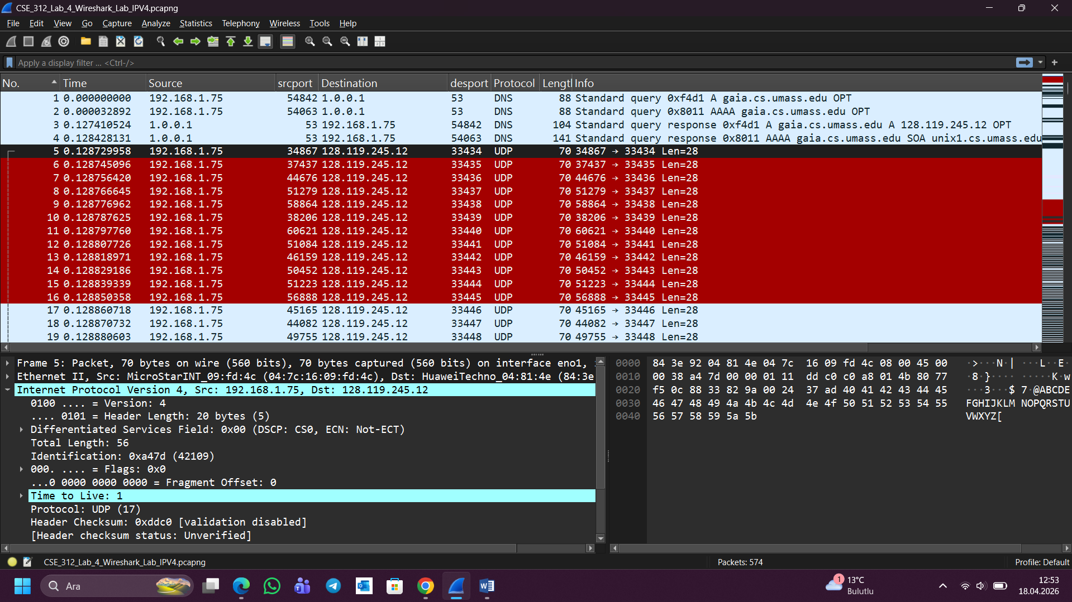

What is the IP address of your computer?
My computer's IP address is 192.168.1.75
What is the value in the time-to-live (TTL) field in this IPv4 datagram’s header?
TTL field value is 1
What is the value in the upper layer protocol field in this IPv4 datagram’s header?
Upper layer protocol field value is UDP (17)
How many bytes are in the IP header?
IP header contains 20 bytes
How many bytes are in the payload of the IP datagram? Explain how you determined the number of payload bytes?
Payload consists of 36 bytes. I have calculated this figure by subtracting the IP Header Length (20 bytes) from the Total Length (56 bytes) of the IP datagram. ($56 - 20 = 36$).
Has this IP datagram been fragmented? Explain how you determined whether or not the datagram has been fragmented?
No, it has not been fragmented. This was done by inspecting the Flag and Fragment Offset fields. The "More Fragments" bit of this datagram was 0 (not set). The "Fragment Offset" is also 0, implying that this is an unfragmented datagram.

Which fields in the IP datagram always change from one datagram to the next within this series of UDP segments sent by your computer destined to 128.119.245.12, via traceroute? Why?
The Identification, TTL, and Header Checksum fields always vary. The ID field varies since it provides a unique identifier for each datagram. The TTL field is different since traceroute increments its value with each set of consecutive datagrams. The Header Checksum field changes as a result of the changes in other field.

Which fields in this sequence of IP datagrams (containing UDP segments) stay constant? Why?
The Version, Header Length, Source IP, Destination IP, and Protocol fields always remain constant.
These fields remain the same as the endpoints are the same, the protocol utilized remains the same (UDP), and the version of IPv4 protocol remains the same across the datagram sequence.

Part 2: Fragmentation

Find the first IP datagram containing the first part of the segment... Has that segment been fragmented across more than one IP datagram?
Yes, the segment has been fragmented across more than one IP datagram. The 3000-byte UDP traceroute message was split into 3 fragments. Wireshark confirms this with the reassembly note: the original data was divided into three separate IP datagrams. The first fragment is packet #228, which has the More Fragments (MF) bit set to 1 and a Fragment Offset of 0.

What information in the IP header indicates that this datagram has been fragmented?
There are two key aspects from the IP header that suggest the occurrence of fragmentation.
These are: Flags: The More Fragments bit is equal to 1 in the first two fragments, which means that the segment will be continued in another datagram.Total Length: The Total Length (usually 1500 bytes for the first two fragments) of each packet is less than 3000 bytes, the length of the initial data. Fragment Offset: The first fragment has a Fragment Offset of 0, but since the More Fragments bit is set to 1, it confirms that this is only the beginning of a larger fragmented datagram.

Now inspect the datagram containing the second fragment... What information in the IP header indicates that this is not the first datagram fragment?
The Fragment Offset field indicates that this is not the first fragment. In the second fragment (the packet immediately following #228), the Fragment Offset value is 185 (which equals 1480 bytes), meaning this datagram carries data starting at byte 1480 of the original payload — not from the beginning. A Fragment Offset of 0 would indicate the first fragment; since it is non-zero here, this is clearly not the first fragment.

What fields change in the IP header between the first and second fragment?
The fields which vary among fragments include:
Fragment Offset: To account for the new offset corresponding to where the information will start in relation to the original datagram (for example, 0 to 1480).

Flags: The More Fragments flag must be set to 1 except for the final fragment, in which case it is set to 0.

Total Length: The length of the final fragment differs from the previous fragments.

Header Checksum: Because of changes to the offset and total length fields, the header checksum needs to be updated.

Remark: The Identification field (value of 0xdce7 as per your screenshot) does not change throughout all the fragments.
